CYBERBULLYING DETECTION & PREVENTION USING
MACHINE LANGUAGE

HARDWARE REQUIREMENT:
- I5 PROCESSOR 12TH GENERATION OR ABOVE
- RAM 16GB OR ABOVE
- SSD 60GB OR ABOVE
- MONITOR
- KEYBOARD AND MOUSE KIT

SOFTWARE REQUIREMENT:
- IDLE PYTHON 3.1.10- https://python.org/downloads/release/python-31014/
- SQLITE 3- pip install sqlite 3
- FLASK 3.0.0- pip install flask
- Tensor flow- pip install tensorflow 2.12.0
- Kears- pip install tensorflow 2.11.0

ENVIRONMENTAL SETUP:
- PYTHON: IDLE
- FRAME WORK: FLASK
- LANGUAGE: PYTHON
- BACK END: SQLITE 3
- TENSOR FLOW
- KERAS

EXISTING SYSTEM SUMMARY:
Existing System presents a robust hybrid ML model for cyberbullying detection in the indian language Bengali on social media. It involves an effective text pre-processing to make the Bengali text data into a useful text format, feature extraction using the TfidfVectorizer (TFID) to get the beneficial information of text data and resampling by Instance Hardness Threshold (IHT) procedure to balance the dataset to avoid overfitting or underfitting problems. In our experiment, we used the publicly available text dataset (44,001 comments).
This study uses a hybrid ML strategy for identifying online Bengali cyberbullying. A number of processes make up the proposed hybrid strategy, including efficient text preprocessing to analyze the text comments, feature extraction to convert the processed text into numerical information, and resampling for balancing the data. After that, we utilized k-fold cross-validation to split the data and applied ML algorithms such as DT, RF, LR and MLP to build the models and finally evaluate the performance using various performance metrics such as accuracy and precision.
The Existing architecture has six significant steps namely data collection, text pre-processing to prepare the data, feature extraction to transform it into numerical information of text data, resampling to balance the data, utilizing k-fold cross-validation to split the data, applying ML algorithms to build the models and finally evaluating the performance using various performance metrics.
By Looking forward, the study points out certain limitations, such as its focus on Bengali and the reliance on traditional ML models without exploring deep learning techniques like BERT and RoBERTa. Future research could broaden the scope by incorporating these advanced models, larger datasets, and applying the model to other languages and cultural contexts to make online spaces safer globally.

EXISTING ARCHITECTURE :

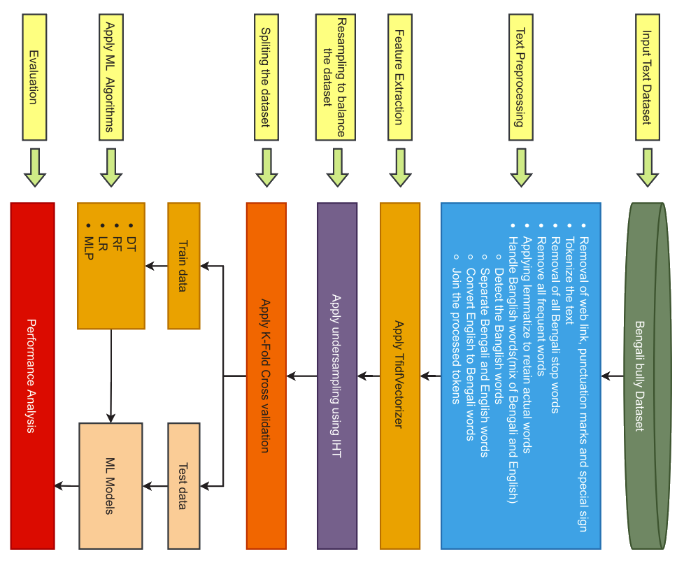

PROPOSED SYSTEM SUMMARY:
The proposed System enhances cyberbullying detection through advanced text preprocessing, feature extraction using TfidfVectorizer, and Enhancing resampling techniques(IHT) by BERT to address class imbalances. Focusing on cyberbullying in English and Tamil-speaking regions, the model combines traditional machine learning algorithms like Logistic Regression and Multilayer Perceptron with Instance Hardness Threshold resampling to improve detection accuracy.
Cyberbullying Detection uses a combination of MACHINE LEARNING techniques such CNNs and LSTM networks to create a robust model for detecting cyberbullying. It Employe’s Advanced Machine Learning model known as BERT model to achieve higher accuracy and better performance in identifying offensive content on social media platforms.
To overcome the Limitations known as Real-Time Detection and Dataset reduction by the existing resampling technique, the proposed system uses the BERT model, known for its advanced contextual understanding and bidirectional processing capabilities, to enhance prediction accuracy.
This approach not only outperforms existing methods but also create an impact on the psychological and online harassment. Future research may explore machine learning models and multi-language datasets to expands the model's applicability across different languages and cultural contexts.

